REST API:
Application programming interface is a set of rules that define how applications or devices can connect to and communicate with each other. A REST API is an API that conforms to the design principles of the REST, or representational state transfer architectural style.

HTTP Method :

https://developer.mozilla.org/en-US/docs/Web/HTTP/Methods

POST, GET, PUT, PATCH, and DELETE.

The Hypertext Transfer Protocol (HTTP) is designed to enable communications between clients and servers.

Project:
Description: I am designing a College Management System project. For the understanding the REST Api’s I was simply implementing 3 features only.

Feature 1: adding student.
Feature 2: add address.
Feature 3: adding student to a class.

STEP 1:
Write SQL Queries with perfect relation.

create database cms_db;
use cms_db;

CREATE TABLE `address` (
`id` BIGINT(8) NOT NULL AUTO_INCREMENT,
`address_line1` VARCHAR(2000) NOT NULL,
`address_line2` VARCHAR(2000) DEFAULT NULL,
`state` VARCHAR(100),
`pincode` INT(20),
PRIMARY KEY (`id`)
);
CREATE TABLE `student` (
`id` BIGINT(8) NOT NULL AUTO_INCREMENT,
`name` VARCHAR(1024) NOT NULL,
`class` VARCHAR(50),
`age` INT(20),
`address_id` BIGINT(8) NOT NULL,
PRIMARY KEY (`id`),
FOREIGN KEY(`address_id`) REFERENCES `address`(`id`)
);
CREATE TABLE `student_class` (
`id` BIGINT(8) NOT NULL AUTO_INCREMENT PRIMARY KEY ,
`class_name` VARCHAR(1024) NOT NULL,
`student_id` BIGINT(8) NOT NULL,
FOREIGN KEY(`student_id`) REFERENCES `student`(`id`)
);

Diagram:
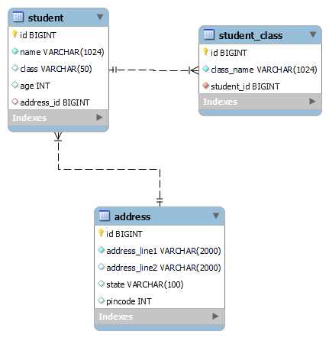

Important Links:
Reverse Engineering:
https://database.guide/how-to-reverse-engineer-a-database-in-mysql-workbench/#:~:text=To%20reverse%20engineer%20a%20database%20in%20MySQL%20Workbench%3A,if%20required%2C%20then%20click%20OK

STEP 2:
1.Create Spring boot project.

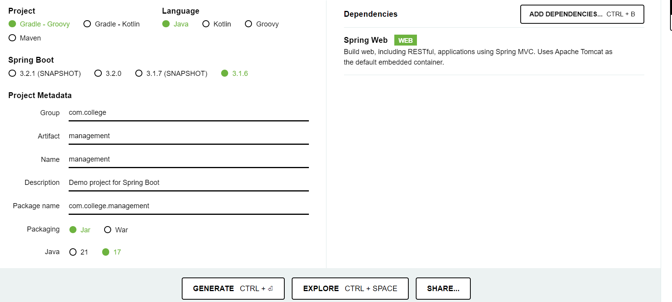
STEP 3:
Follow this step to import Gradle project to STS IDE.

- Extract management zip
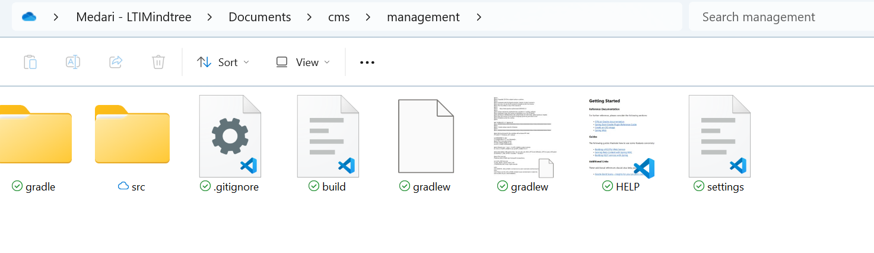
- Select “Existing Gradle Project”
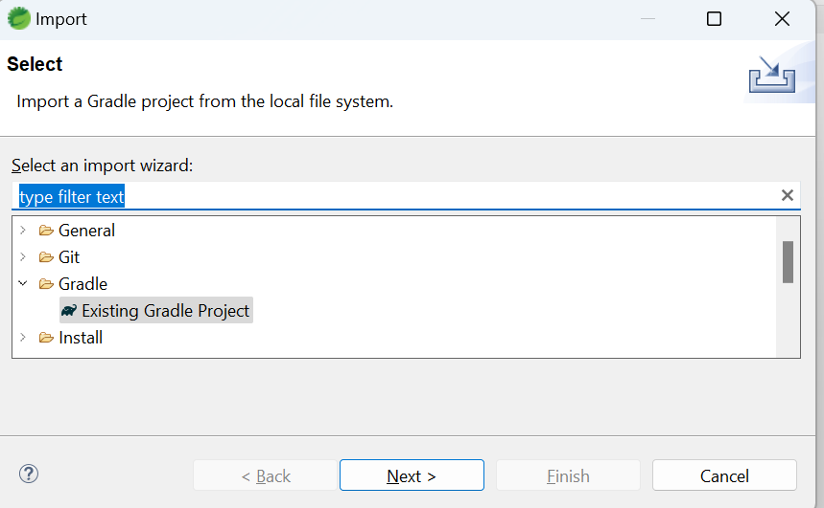

- Select project path -> next
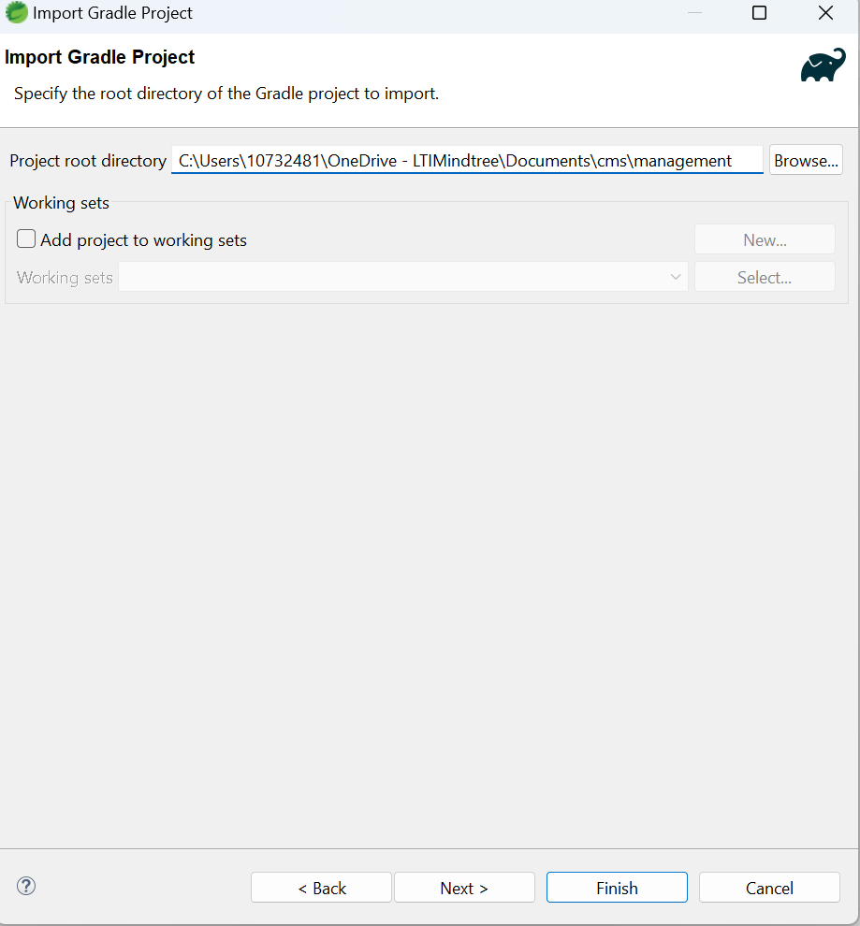
- Next
- 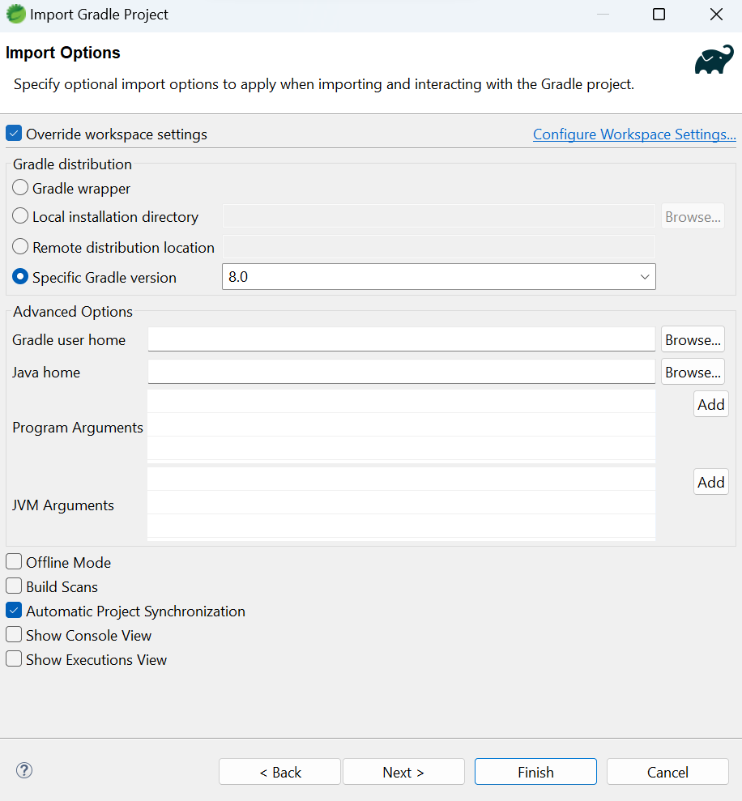
- Finish
- 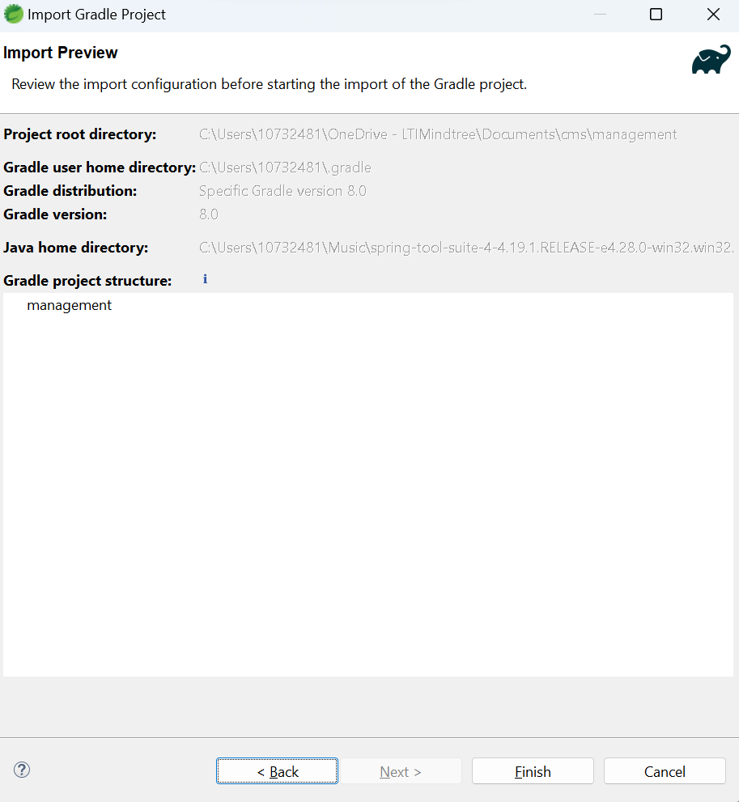

- Entire Flow is: Select “Existing Gradle Project” -> Select project path -> next -> next -> finish.

- Project package structure:

- 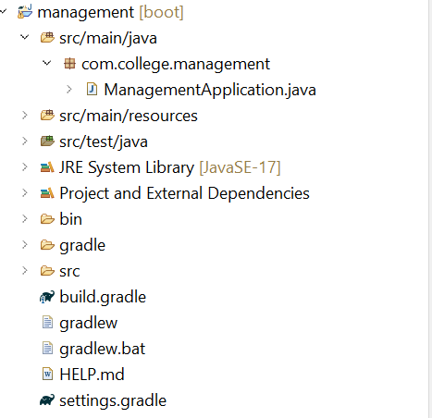

STEP 4: Database Connection
Here I am using MySQL database and JPA Connectivity.

1.For this add 2 dependencies
implementation group: 'com.mysql', name: 'mysql-connector-j', version: '8.1.0'

implementation group: 'org.springframework.boot', name: 'spring-boot-starter-data-jpa', version: '3.0.9'

Ref:
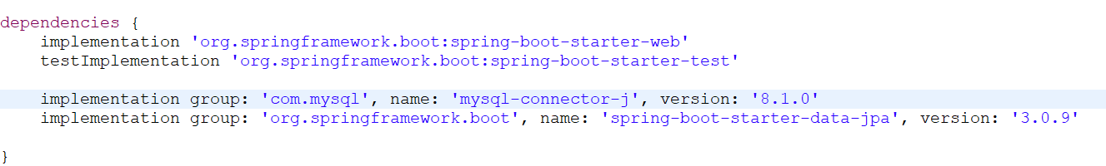
2. build the project and clean project(optional).

3. Add Database credentials in application.properties file. Spring boot will take care of connecting db if we are providing this credentials .

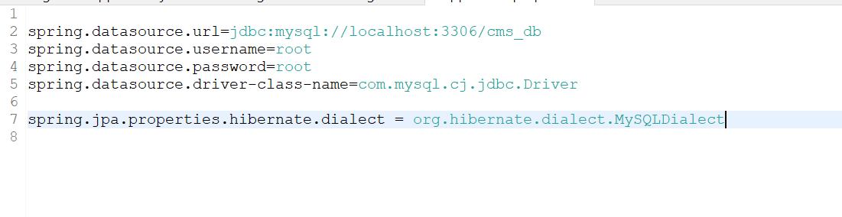
Note: More info or internal work please ref YouTube videos.

STEP 5: Create Project Architecture (Empty Packages)

Add Controller, DTO, Entities, Repositories and Services package. We can add more packages as our requirements for now simply added this packages.

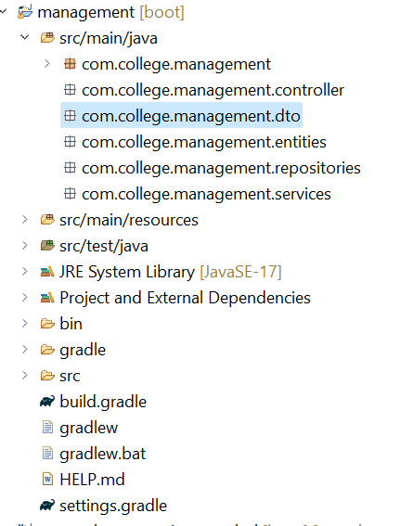

STEP 5: Develop Code for this Project.

1. Write Entity files first. I have 3 tables so I can create 3 entity files.

Address Entity:

@Entity
@Table(name = "address")
public class Address {
@Id
@GeneratedValue(strategy = GenerationType.IDENTITY)
private Long id;

@Column(name = "address_line1", nullable = false, length = 2000)
private String addressLine1;

@Column(name = "address_line2", length = 2000)
private String addressLine2;

@Column(name = "state", length = 100)
private String state;

@Column(name = "pincode", length = 20)
private Integer pincode;

//Add Getters and Setters
}

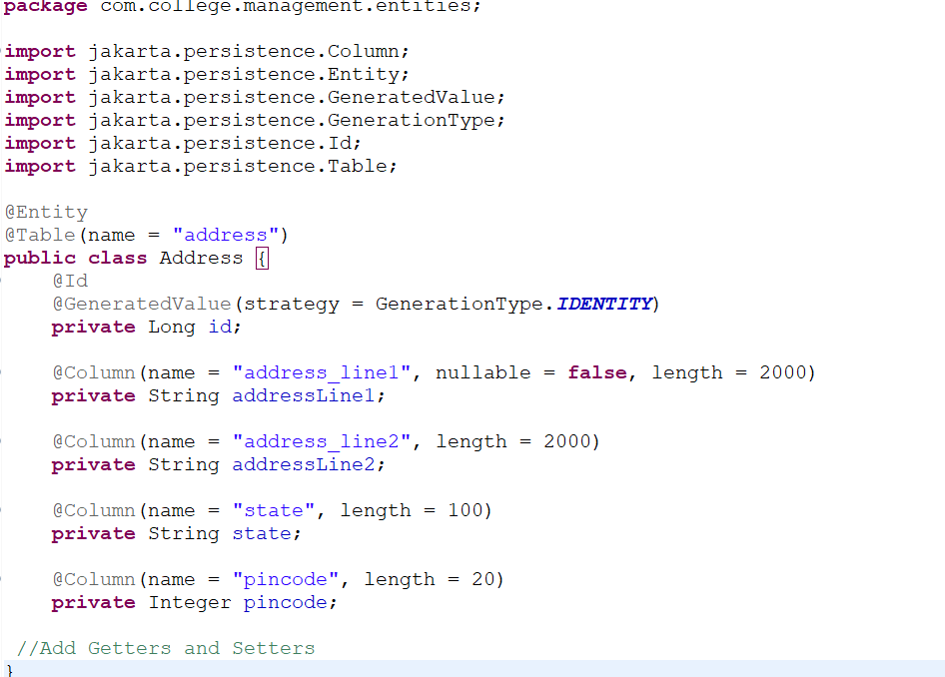

Student Entity:
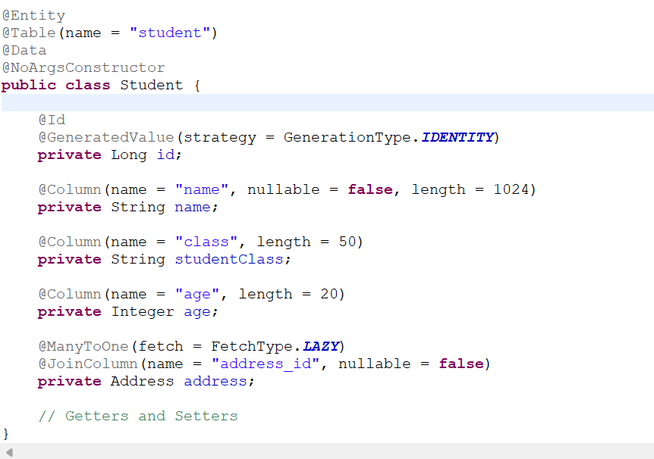

StudentClass Entity:
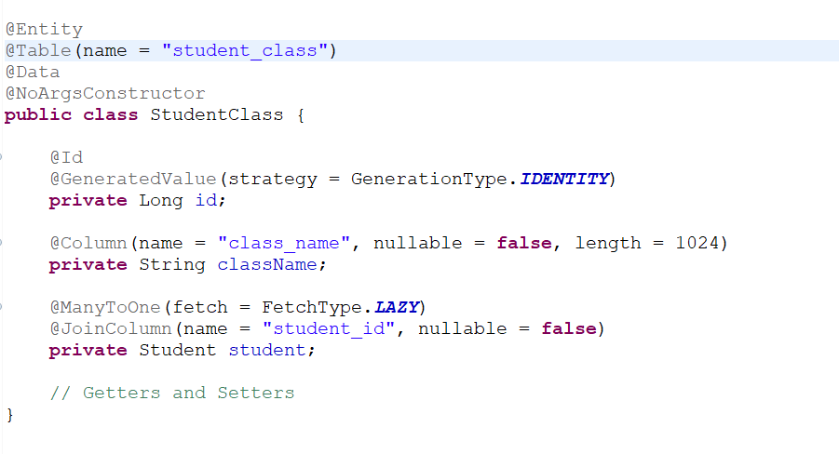

2. Add repositories for the entities.

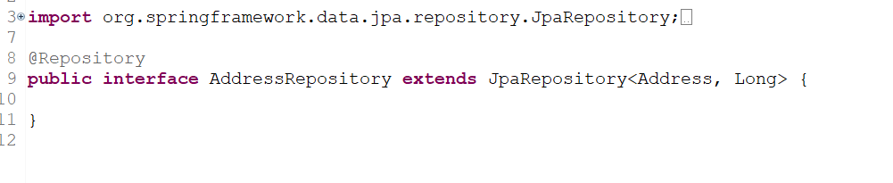

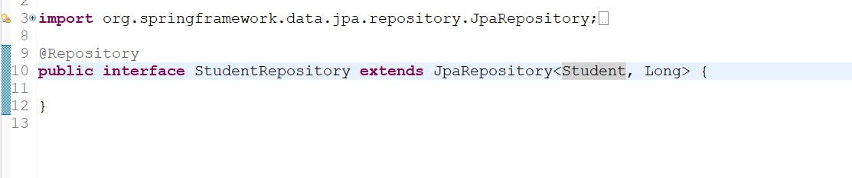

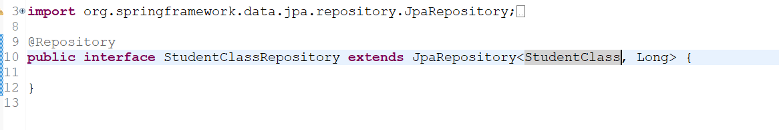

3. Now I am implementing API’s for Address Module. Adding Controller and business logic.

POST API:

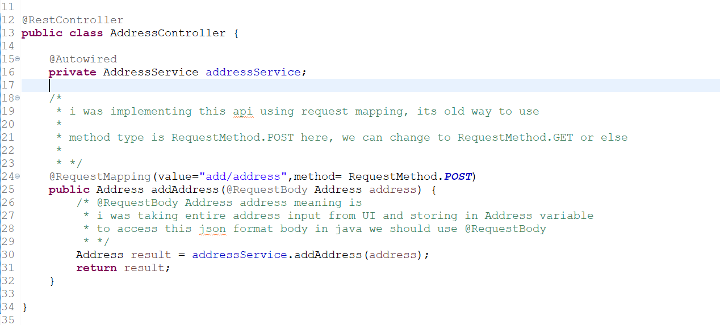

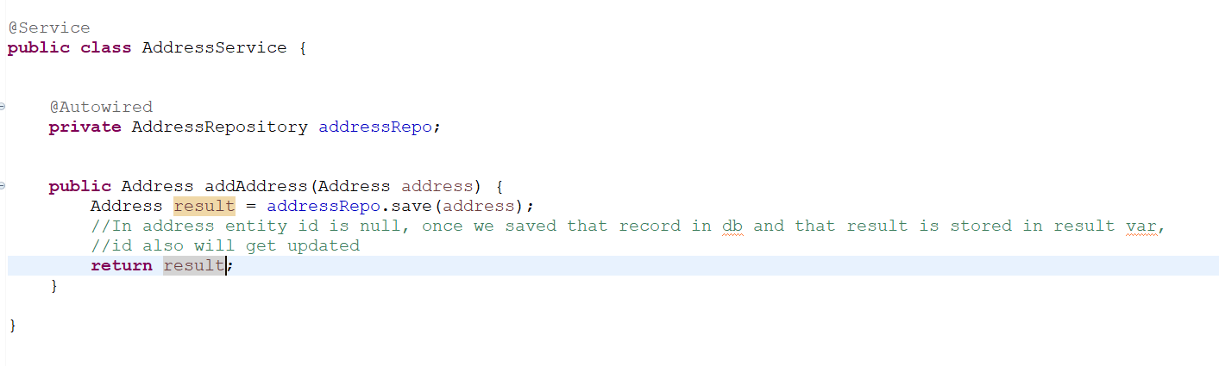

GET API:

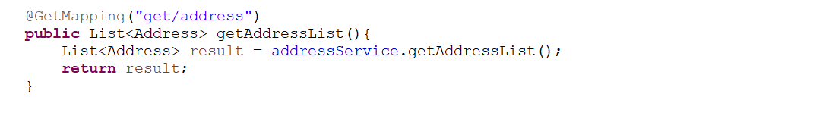

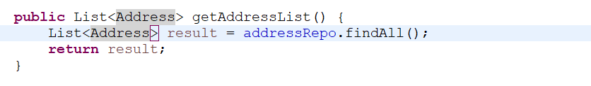

GET API with Path Variable:

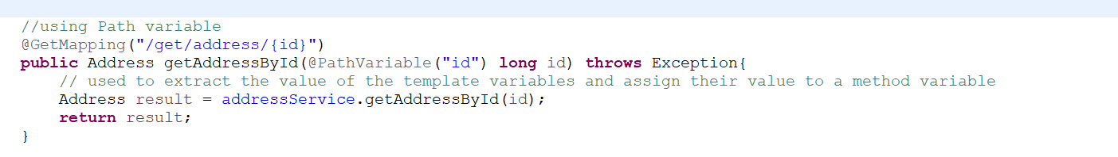

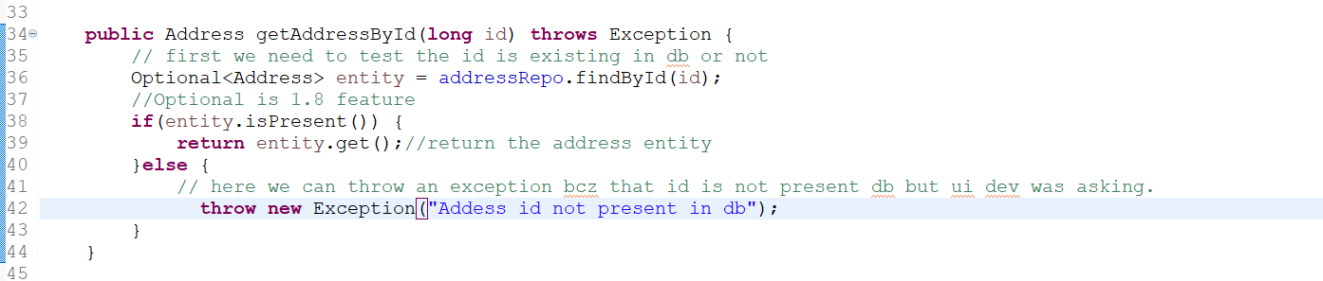

GET API with Path Param:

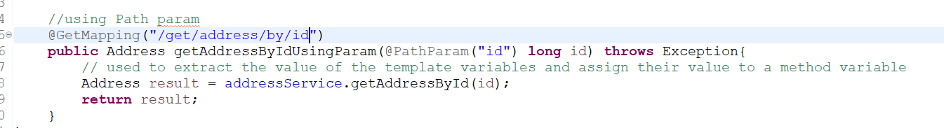
Note: I didn’t write any separate business logic bcz I used existing method.

